Learning Evidence – Jacob Booth 221530207
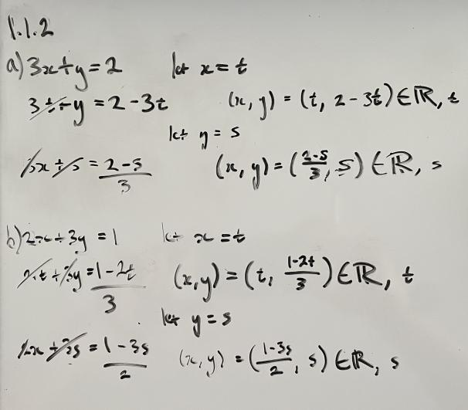
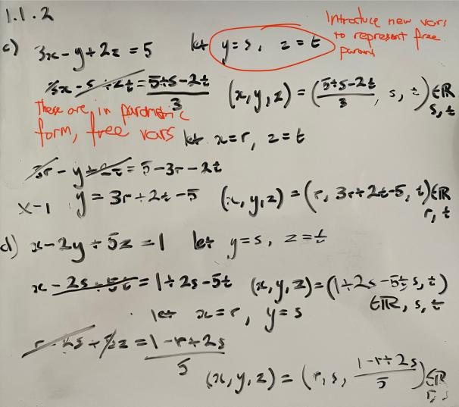

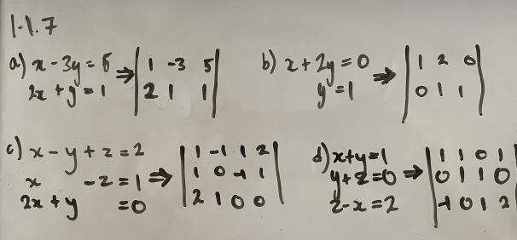
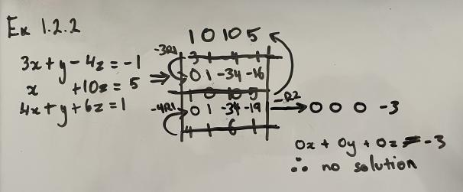
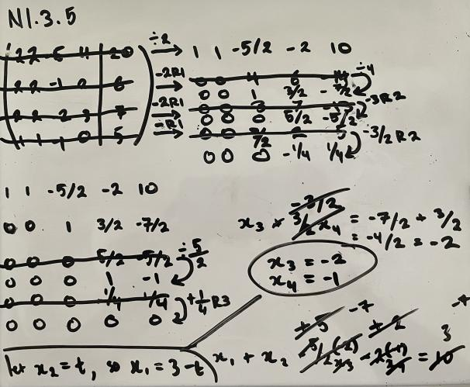
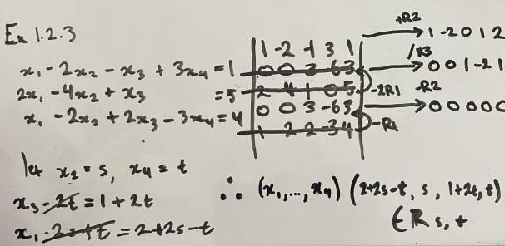
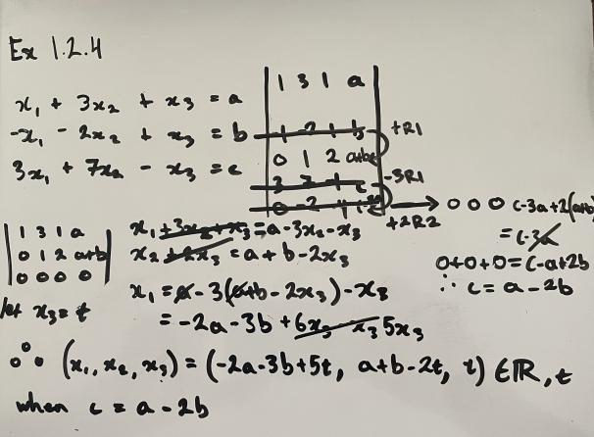
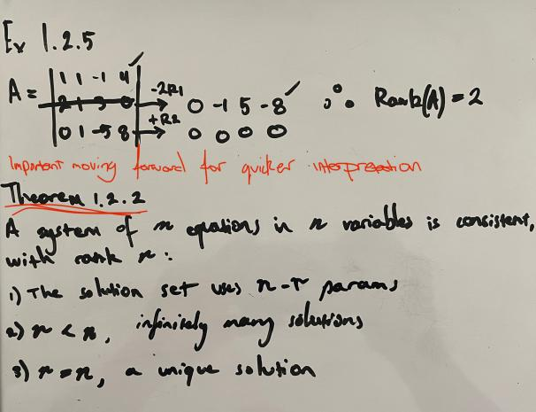

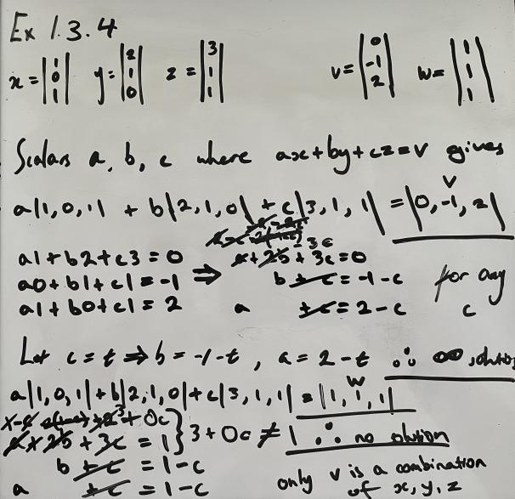
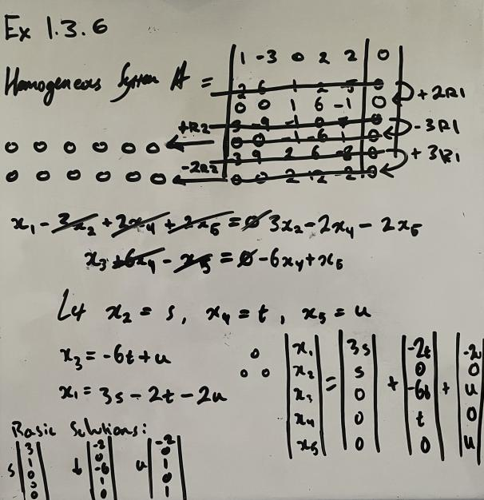
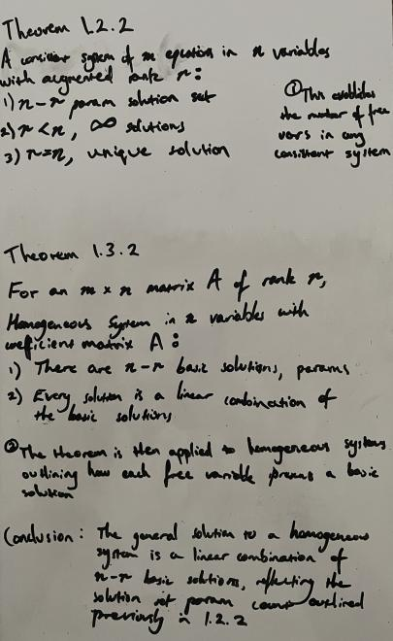
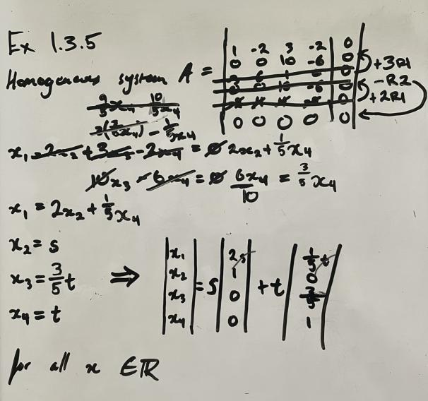
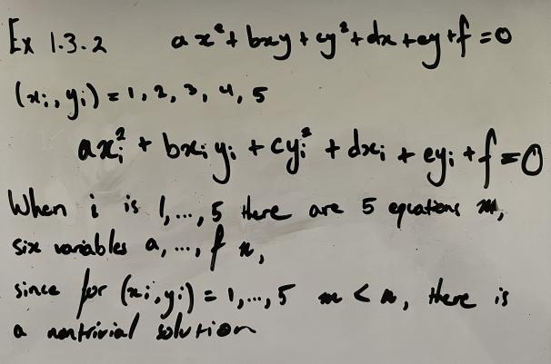

Here I make the link between Theorem 1.2.2 and 1.3.2 to establish the nature of solutions by observing rank, and how the rank/var balance implies the number of combinations of basic solutions for homogeneous systems, creating the general solution.

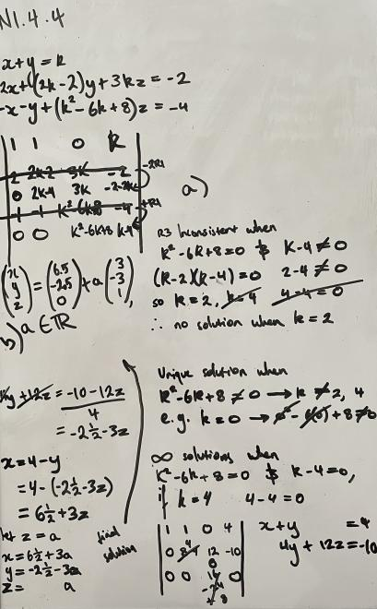
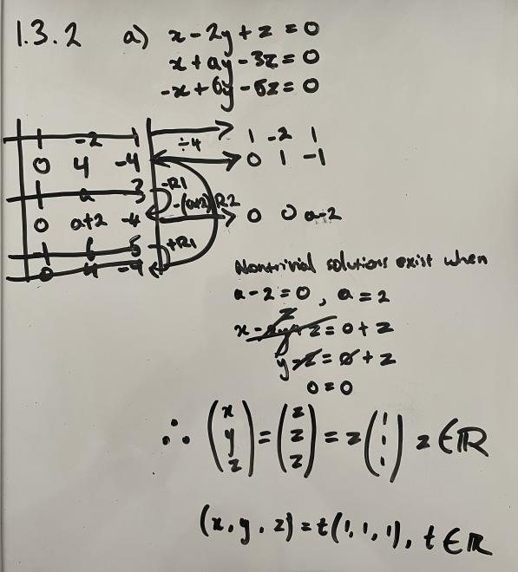
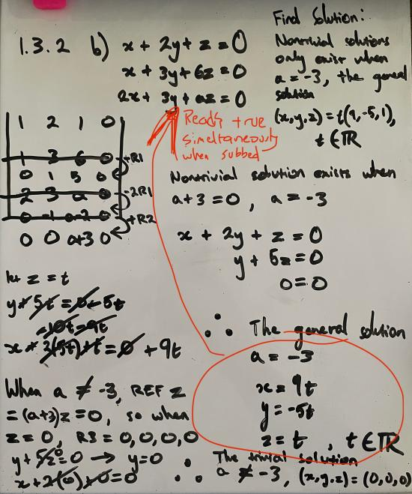
Exercises N1.4.4, 1.3.3 a and b were particularly good examples of the essence of this module. We have a good mix of unique, trivial/nontrivial (homogeneous), and a general solution in parametric form. These 3 problems highlight the largest amount of underlying prerequisite concepts as proof of clarifying the solution.
The areas where I made most mistakes for this module were the slightly larger 3x4 + matrices, since my train-of-thought and problem-depth-awareness become a little fuzzy the longer I spend on a single question. I relied on row-swapping for initiating Gaussian Elimination as smoothly as possible, and I had to take my time to avoid mini-mistakes leading to cascading errors. Although the speed that I can solve these problems is on the slower side, it’s been incredibly important for ensuring I don’t get lost in the middle of my problem. Taking the time to clarify where I’m up to and documenting each step by hand has gone a long way toward helping me keep my head on straight through longer multi-step problems. The shift over to a whiteboard-workflow has been much more effective for this whole process than my previous pen/paper approach, so I will definitely lean into this style of note-taking and solving going forward.

Additionally, my solution for problem 6 in the Self Assessment could have been done a little more gracefully. Part of balancing stress with timeliness is taking the approach which strikes me as intuitive first, but had I considered the matrix properties more carefully, I would have noticed the inter-dependencies that popped up as nested sub-problems while I was substituting. The second phase required substitution, but the first phase could have been more gracefully solved had I opted straight for Gaussian Elimination. Reflectively, maintaining stress and taking confidence in my capabilities to implement the module concepts is increasingly important. Moving forward, I’ll be considering more thoroughly how I can approach each problem based on the emphasis of the module, and work more on addressing my conceptual-toolkit before getting stuck into a solution.

